=
Ignite Your Talent Strategy
Talent Summit 2018
  - PRESENTED BY:
  - Joan Schatz, Co-President at Park Industries
  - Kelly Hansen, VP of HR at Park Industries

Ignite Your Talent Strategy |  | Things to Consider  • • •
- Engagement Survey to assess culture
- Compare your metrics to others in a like industry/benchmark
- Identifying High Potentials, create developmental plans to grow from within
- Assess talent needs vs. talent capabilities
- Training for growth, leverage funding options
- Sourcing strategy should represent your brand

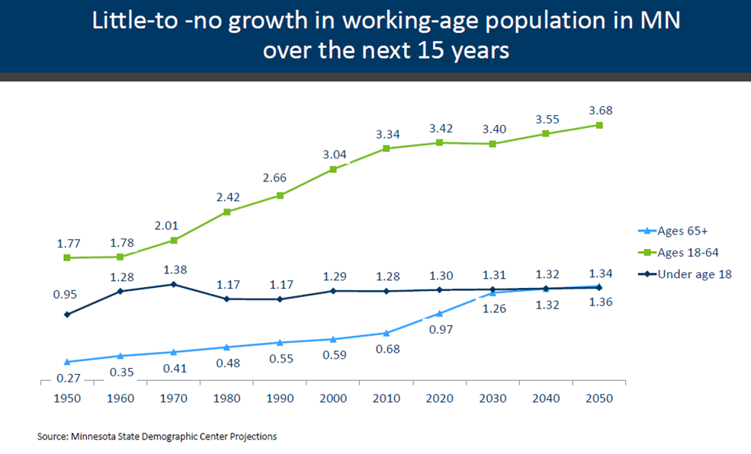
“The Bureau of Labor Statistics reported that April closed with 6.7 million job openings. May ended with just over 6 million people the BLS classifies as unemployed, continuing a trend this year that has seen openings eclipse the labor pool for the first time. At some point that gap will have to close. Economists expect that employers are going to have to start doing more to entice workers, likely through pay raises, training and other incentives.”

Key Takeaways
- The labor shortage isn’t going to change, only you can change the outcome for your business
- Culture is critical to addressing your talent gaps
- Ensure you have the right leaders in place to fulfill your talent needs in to the future
- You have to consider the entire talent lifecycle
- If you do all the right things around talent strategy, you will reap positive benefits across the organization

Strategies to Implement Now
- Assess your culture
- Assess your talent, right person/right seat
- Address talent gaps and create an ongoing strategy
- Understand “why” you can’t find talent or can’t keep talent
- Curate your future talent needs

Meaningful Metrics to Track
- Desirable vs. Undesirable turnover
- Referral Rate
- Retention Rate
- Internal Growth Rate
- Days to Offer

